**GitHub Repository & Documentation:** [**https://github.com/lemeow125/NetworkDocumentationProject**](https://github.com/lemeow125/NetworkDocumentationProject)

**High-res Image:** [**https://github.com/lemeow125/NetworkDocumentationProject/blob/master/diagram.drawio.png**](https://github.com/lemeow125/NetworkDocumentationProject/blob/master/diagram.drawio.png)

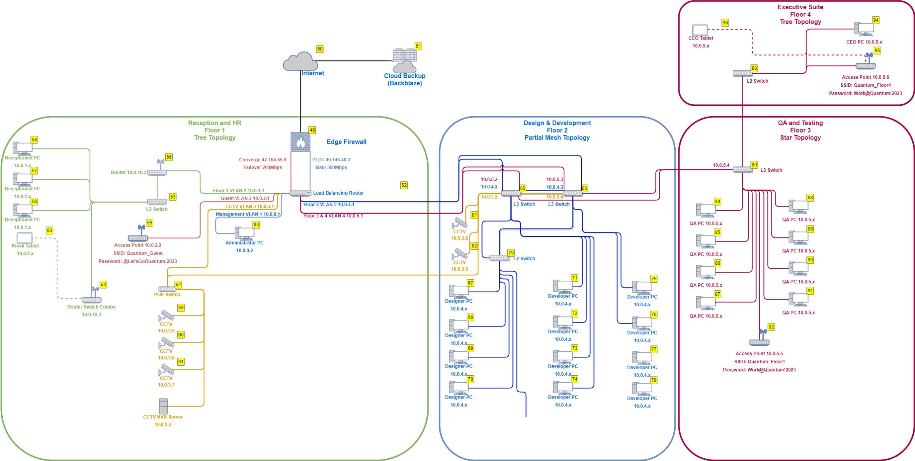**Members: Keannu Bernasol, James Cañasa, Kim Arandid, Aarone Santos**